Discuss and Debate
Student’s Name
Institutional Affiliation

Discuss and Debate
Introduction
This paper explores the heart as an organ with dual innervation and diagrammatically explains the actions of the sympathetic and parasympathetic nervous system of the organ. It also explores the main nerve plexus in the body, the layers of the eye and their functions, the three parts of the ear and their functions, structures, and functions of the taste and smell senses and the autonomic nervous system.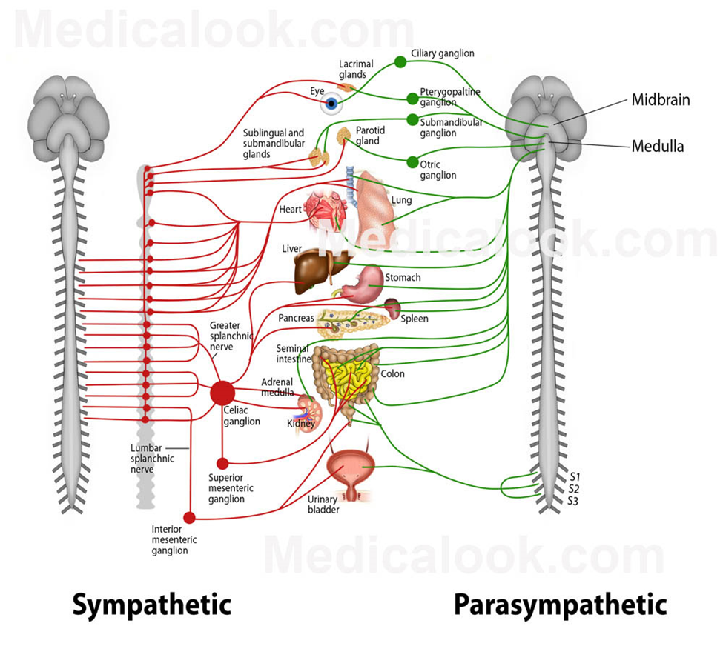

A prime example of an organ with dual innervation is the heart. It is innervated by both the sympathetic and parasympathetic fibers. Sympathetic neurons are responsible for the increase in the heart rate while the parasympathetic neurons are responsible for the decrease in the rhythm of the heart. Sympathetic neurons release adrenergic stimulation whilst parasympathetic neurons release cholinergic stimulation which decreases the heart’s rhythm.
The main nerve plexus in the body are: the cervical plexus which innervates the diaphragm, brachial plexus which serves the chest, arms, shoulders and the hands, the lumbar plexus which innervates the lower abdomen region and the anteromedial thigh, the sacral plexus which serves the pelvis, buttocks, thighs, and feet and the coccygeal plexus which serves the coccyx (Kerr, 2015).
The three layers of the eye are cornea, iris, and retina. The function of the cornea is to help focus light that is entering the eye. The iris the colored part of the eye and it controls the amount of light entering the eye. The middle opening of the iris is known as the pupil. The Retina acts like the film in a camera to create an image which is sent to the brain (Oyster & Haver, 2014).
The human ear has three parts; the outer ear, the middle ear, and the inner year. The outer ear consists of the auricle (pinna), the ear canal and the eardrum outer layer (tympanic membrane). The function of the outer year is to collect sound whereby sound travels through the pinna and the ear canal and ends at the eardrum. The middle ear consists of the eardrum, cavity, and three ossicles (Mehrgardt & Mellert, 2017). The three ossicles normally transmit sound from the outer ear to the inner ear. The inner ear consists of the oval window (connects the middle ear with the inner ear), cochlea (transforms sound into signals sent to the brain) and the auditory tube (for draining fluid from the middle ear into the throat).
Gustation (taste) and olfaction (smell) are the most interconnected senses in the body. Olfaction enables animals to sense the presence of food and other animals. Taste or gustation, on the other hand, allows animals to discriminate between types of food. The olfactory cells are located at the upper part of the nasal cavity in the olfactory region (Stevenson & Boakes, 2004). Olfactory epithelium consists of 15 million bipolar neuronal cells. Their dendrites have short cilia at the end and these cilia dip into the hydrophilic mucus. Taste receptors are located in the taste buds which are located in small structures called papillae. Papillae are found on the surface of the tongue and esophagus. Humans have the capability of differentiating five basic tastes of bitter, sour, salt, umami, and sweet. There are as many as 10,000 taste buds with 100 sensory cell in each of them (Stevenson & Boakes, 2004).
The autonomic nervous system is the part of the nervous system which controls the internal organs without any conscious recognition or effort by the organism. It operates independently of the voluntary control of the body. Imbalances in this system can create problems in the body such as diarrhea, bloating, constipation, heart failure, and sweating abnormalities. Such disorders occur due to autonomic dysfunction which caused when the autonomic nervous system nerves are damaged (Gabella, 2011).

References

Gabella, G. (2011). Autonomic nervous system.
Kerr, A. T. (2015). The brachial plexus of nerves in man, the variations in its formation and branches. American Journal of Anatomy, 23(2), 285-395.
Mehrgardt, S., & Mellert, V. (2017). Transformation characteristics of the external human ear. The Journal of the Acoustical Society of America, 61(6), 1567-1576.
Oyster, C. W., & Haver, N. (2014). The human eye: structure and function (Vol. 1, No. 01). Sunderland, MA: Sinauer Associates.
Stevenson, R. J., & Boakes, R. A. (2004). Sweet and Sour Smells: Learned Synesthesia between the Senses of Taste and Smell.

